Lesson 11 Demo 2
Manage VM Sizes

Objective: To manage VM size

Tools required: Azure account with administrator access

Prerequisites: None

Steps to be followed:
- Managing VM size

Step 1: Managing VM Size
1.1 Log in to the Azure portal at https://portal.azure.com
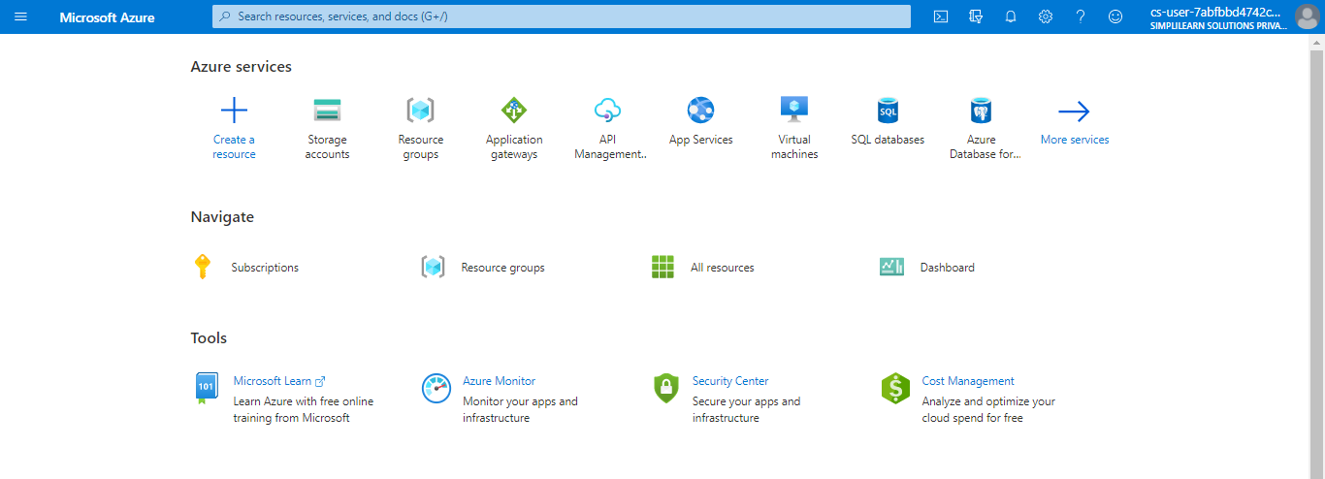

1.2 Search for virtual machines in the Azure portal
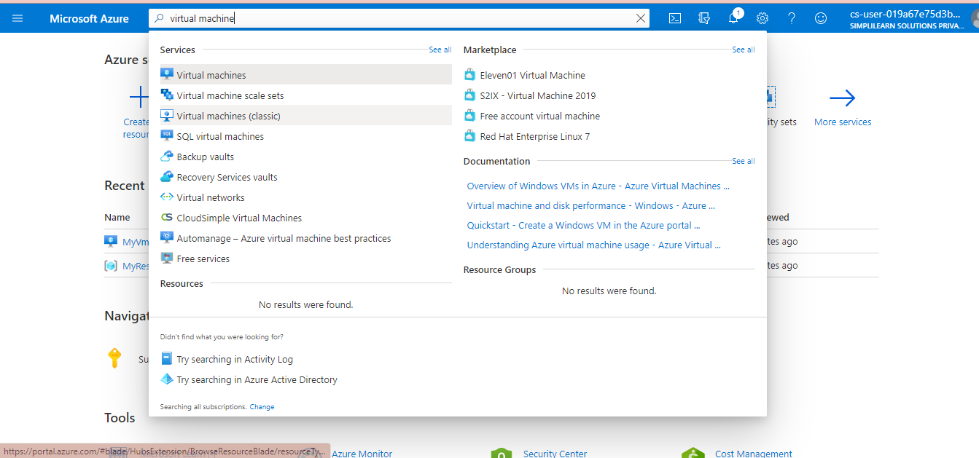

1.3 Under Services, select Virtual machines

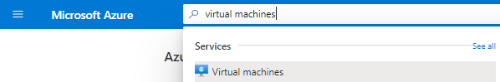

1.4 Click on the Azure VM that you want to resize
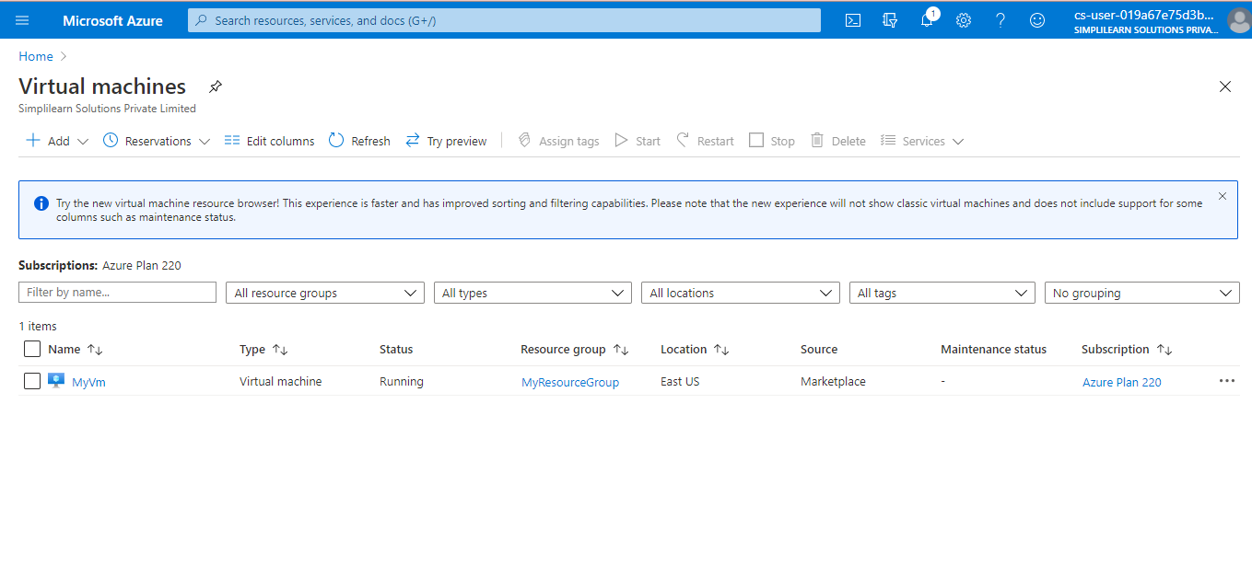
1.5 In the left menu, select Size under Settings

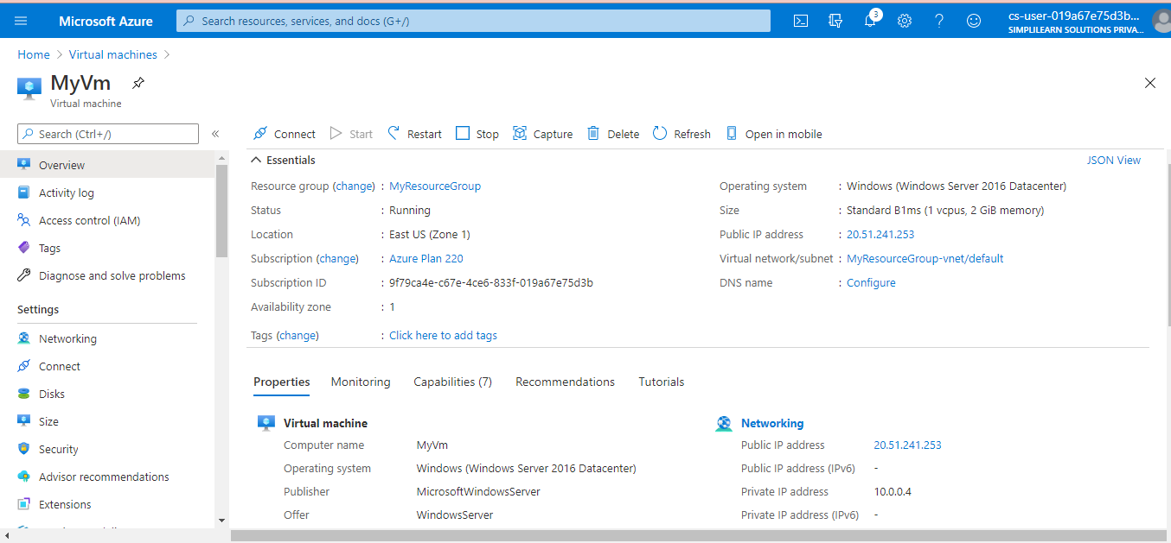

1.6 Pick a new size from the list of available sizes and then select Resize
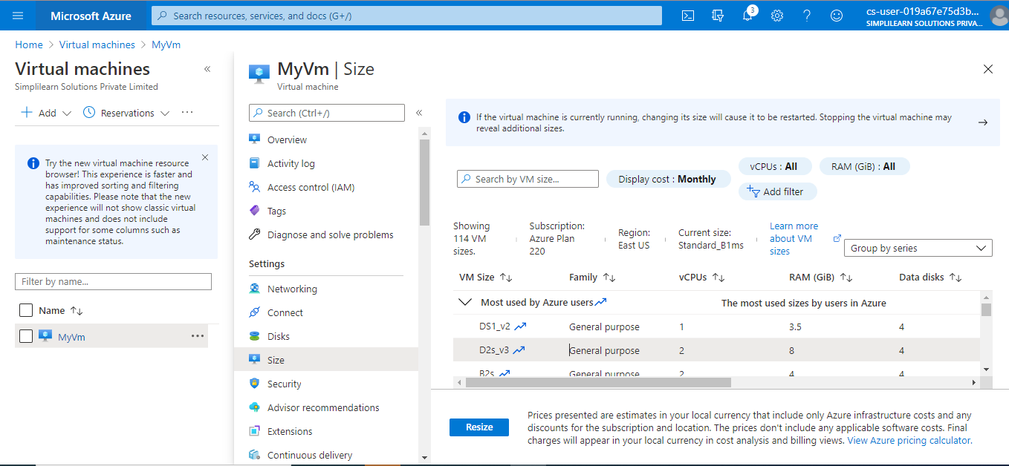

Wait for a few seconds, your VM will be resized.

